
SRM Institute of Science and Technology
BATCH 2/SET B

College of Engineering and Technology
DEPARTMENT OF ECE
SRM Nagar, Kattankulathur – 603203, Chengalpattu District, Tamilnadu
Academic Year: 2022-23 (EVEN)
Test: CLAT-3 Date: 03/05/2023
Course Code & Title: 18ECE221T Radar and Navigational Aids Duration: 10.30 A.M – 12.10 PM
Year & Sem: III Year/ VI Sem Max. Marks: 50
Course Articulation Matrix:
S.NO | 18ECE221T- Radar and Navigational Aids | Program Outcomes (PO) |  |  |  |  |  |  |  |  |  |  |  | Program Specific outcomes (PSO)
S.NO | Course Outcomes (CO) | 1 | 2 | 3 | 4 | 5 | 6 | 7 | 8 | 9 | 10 | 11 | 12 | 1 | 2 | 3
1 | Describe the principle operation of radar with the help of range equation and parameters | 3 | 2 | - | - | - | - | - | - | - | - | - | - | - | - | -
2 | Apply Doppler principle to radars and hence comprehend the features of different types of radar | 3 | 2 | - | - | - | - | - | - | - | - | - | - | - | - | -
3 | Analyze the reception of Radar signals under noise and different propagation modes | 2 | - | - | 3 | - | - | - | - | - | - | - | - | - | - | 1
4 | Illustrate the functions of various parts of Radar transmitters and Receivers | 3 | 2 | - | - | - | - | - | - | - | - | - | - | - | - | -
5 | Outline the principle of navigation with aids of various navigation systems | 3 | - | - | 2 | - | - | - | - | - | - | - | - | - | - | 1

Part - A
(10 x 1 = 10 Marks)
Instructions: Answer all
Q. No | Question | Marks | BL | CO | PO
1 | A major disadvantage of klystron amplifier is:  A. Low power gain B. Low bandwidth  C. High source power D. Design complexity  Answer: B. Low bandwidth | 1 | 1 | 4 | 1
2 | Solid state transmitter has a peak power of  A. 50 kW B. 60 kW C. 28 kW D. 40 kW  Answer: C. 28 kW | 1 | 1 | 4 | 1
3 | Calculate the output SNR of the amplifier given the input SNR is 37 dB and the noise figure of the device is 2?  A. 18.5 dB B. 34 dB C. 44 dB D. 70 dB  Answer: B. 34 dB | 1 | 1 | 4 | 2
4 | Broad banding of a multi-cavity klystron can be accomplished by  A. synchronous tuning B. drift space  C. velocity modulation D. stagger tuning  Answer: D. stagger tuning | 1 | 1 | 4 | 1
5 | Select the display type that is intensity modulated and rectangular coordinate with range indicated in horizontal axis and elevation angle by the vertical axis  A. PPI B. A scope C. E scope D. CRT display  Answer: C. E scope | 1 | 1 | 4 | 1
6 | GPS consists of a constellation of  A. 6 satellites B. 24 satellites C. 8 satellites D. 3 satellites  Answer: B. 24 satellites | 1 | 1 | 5 | 4
7 | Pick the correct operating frequency range of TACAN  A. 900 MHz – 1215 MHz B. 3 GHz – 30 GHz  C. 10 MHz – 500 MHz D. 10 KHz – 100 KHz  Answer: A. 900 MHz – 1215 MHz | 1 | 1 | 5 | 4
8 | The receiver used in ILS is typically ______ channel receiver  A. Single B. Dual C. multi D. In Phase  Answer: B. Dual | 1 | 1 | 5 | 1
9 | ILS has a channel width of  A.50 KHz B.100 KHz C.20KHz D.10 KHz  Answer: A. 50 KHz | 1 | 1 | 5 | 1
10 | _________ Error arising from echo signal of neighboring objects  A. Site B. Polarization C. abnormal propagation D. Instrumental  Answer: A. Site | 1 | 1 | 5 | 4
Part – B (4 x 4 = 16 Marks)
Section B1
Instructions: Answer ANY 2 Questions
11 | Discuss the benefits of π mode of operation of Magnetron.  Answer:  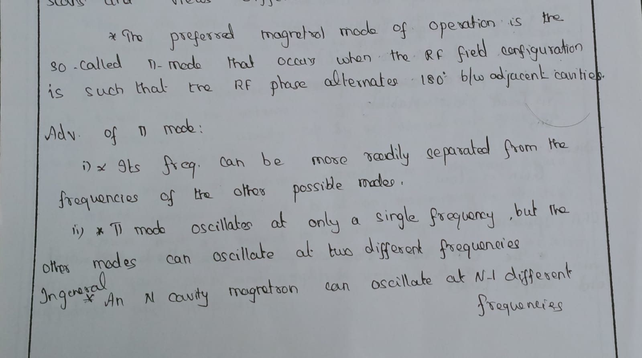 | 4 | 2 | 4 | 1
12 | Determine the internal noise power of a microwave amplifier operating with a bandwidth of 500 MHz and a specified noise figure of 2.5.dB.  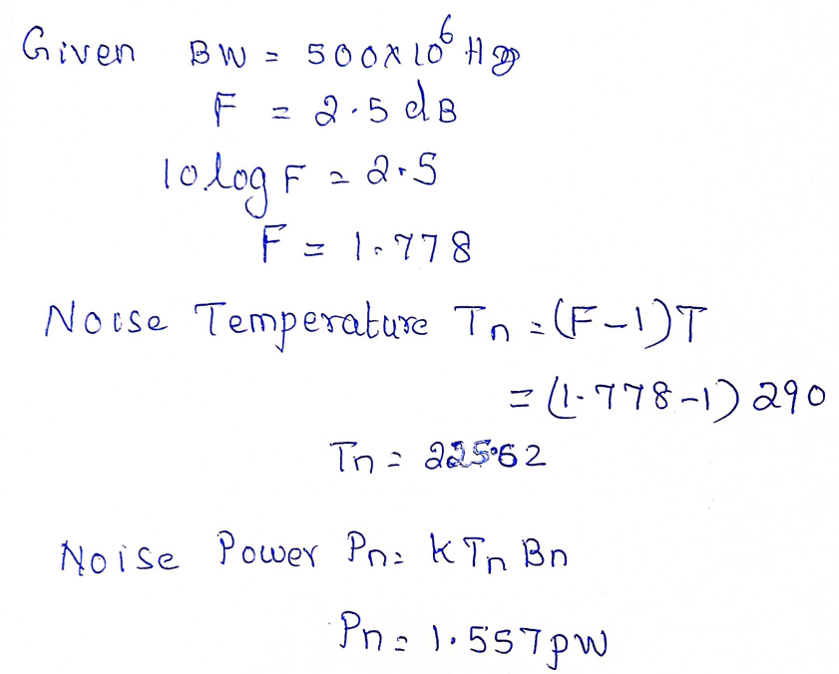 | 1 mark  1 mark  2 mark | 2 | 4 | 2
13 | The noise figure of the individual stages of a two-stage amplifier is 2.03 and 1.54 respectively. The available power gain of the first stage is 62. Evaluate the overall noise figure and equivalent noise temperature.  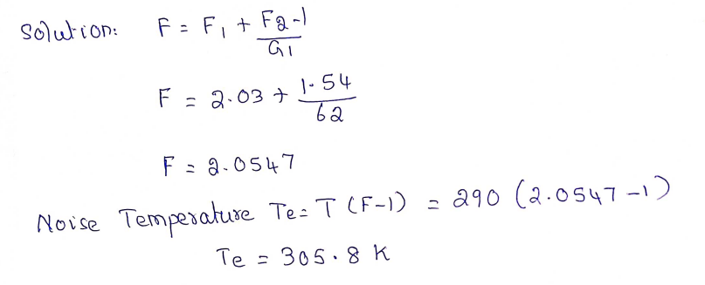 | 2 marks  2 marks | 3 | 4 | 2
Section B2
Instructions: Answer ANY 2 Questions
14 | Draw the block diagram of TACAN equipment  Answer:  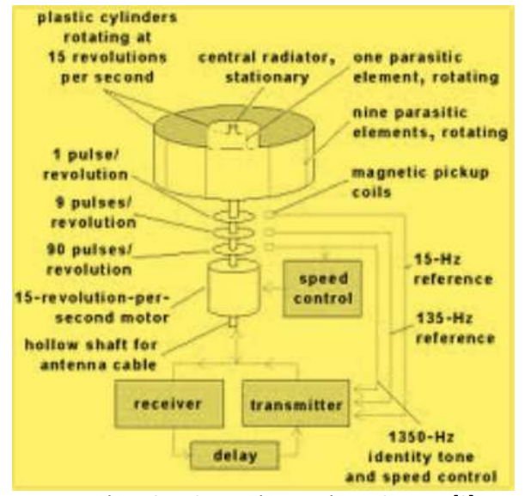 | 4 | 1 | 5 | 1
15 | Adcock antenna is designed to eliminate polarization errors. Justify the statement.  Answer:  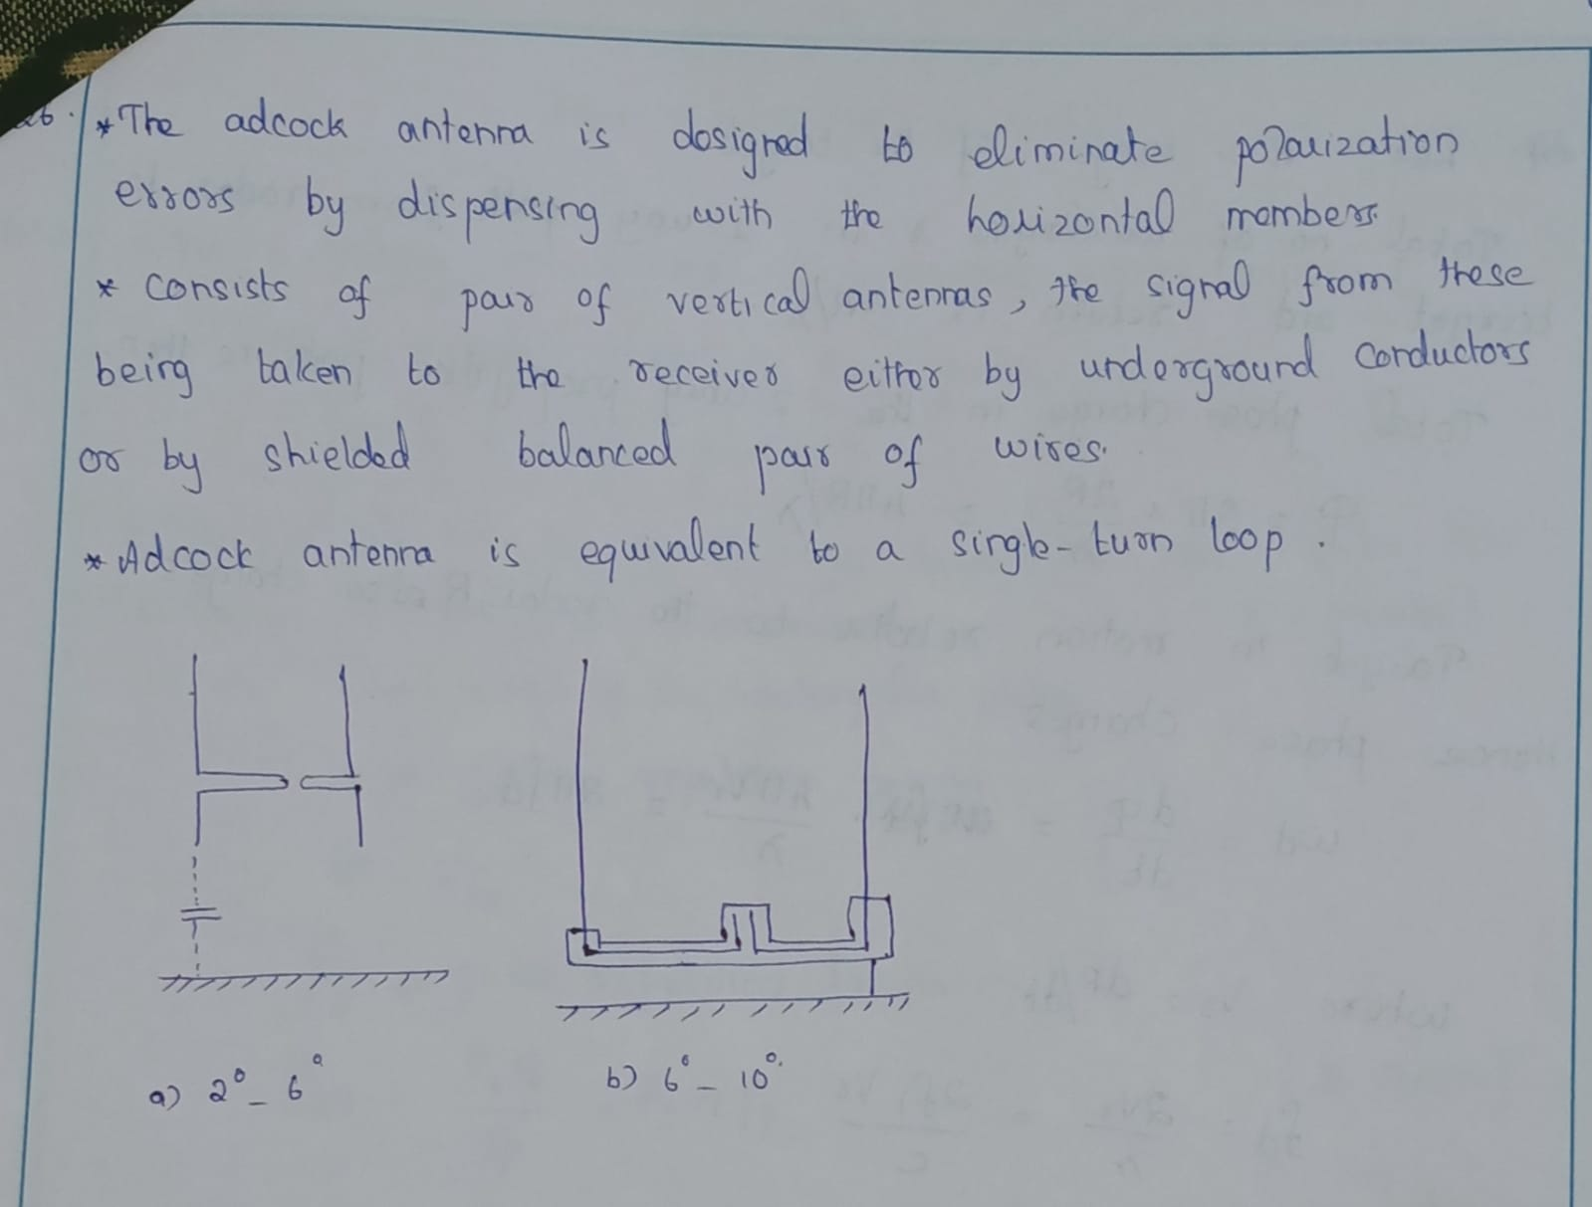 | 4 | 3 | 5 | 2
16 | Brief about any one navigation system which is used in hand held devices.  Answer:  GPS is a ranging system. It is based on time-of-arrival measurements. It is very accurate. For that GPS uses atomic clocks. To provide continuous 3-D navigation solution to dynamic users, sufficient numbers of high-altitude satellites are required. GPS satellites are in 11 hours, 57 minutes (approx. 12 hours) orbits at an altitude of 11,000 nmi. Each GPS satellite transmits signals at two frequencies at L-Band (L1 - 1575.42 MHz and L2 - 1227.6 MHz). This signals contain satellite-unique pseudorandom noise (PRN) codes. Using this range can be calculated. GPS provides two positioning services namely Precise Positioning Service (PPS) and Standard Positioning Service (SPS). SPS is available free of charge to any user worldwide. PPS is for authorized user only i.e., US and NATO military only | 4 | 2 | 5 | 4
Part – C
(2 x 12 = 24 Marks)
Instructions: Answer any two (out of four)
17 | - Explain how the desired bandwidth, power and efficiency are achieved in a 3- cavity klystron power amplifier with a neat diagram  Answer:  Diagram – 5 Marks  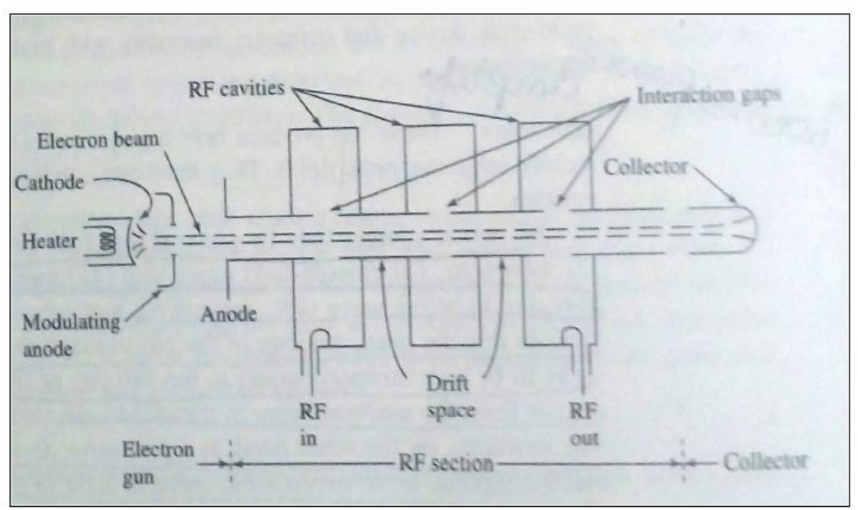  Explanation – 7 Marks  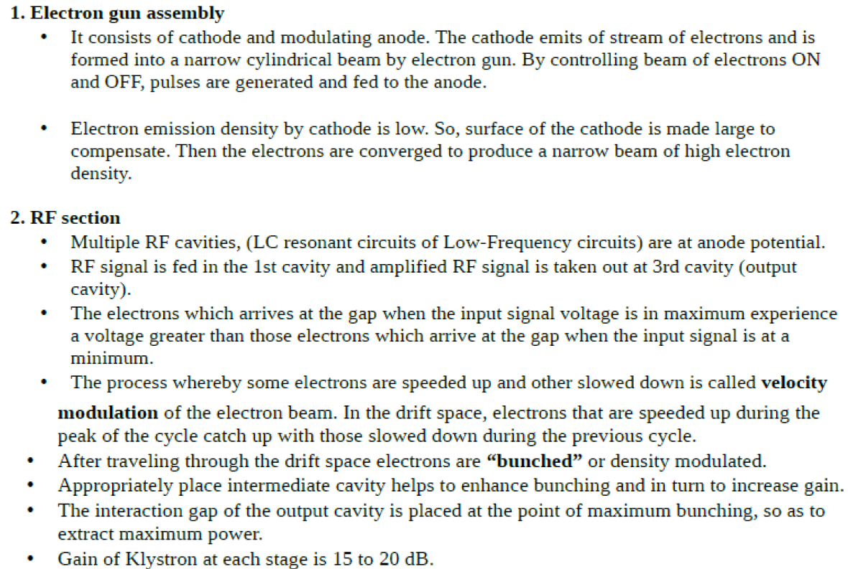  (OR)  - “I am a receiver most commonly used in RADAR Systems”. Identify me and with a neat block diagram, explain the aforementioned RADAR receiver.  Answer:  Identification: 2 Marks  Diagram – 4 Marks  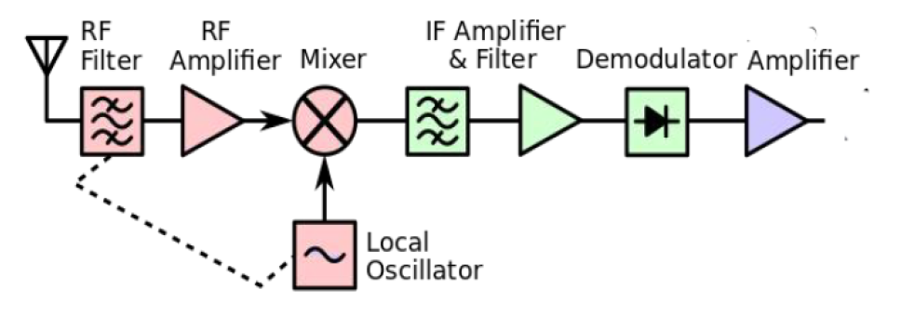  Explanation – 6 Marks  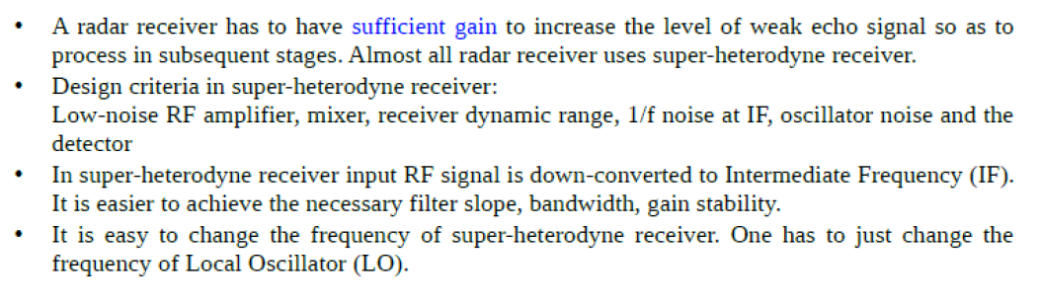 | 12 | 3 | 4 | 1
18 | - Design a hyperbolic DECCA navigation system that operates with four transmitting stations in master slave configurations and receiver to receive the signals in common harmonic frequency.  Answer:  Identification - 2 marks  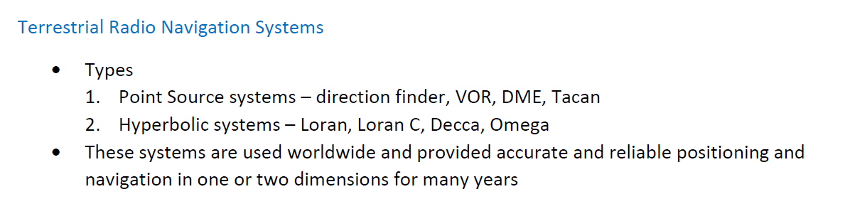  Diagram – 4 Marks  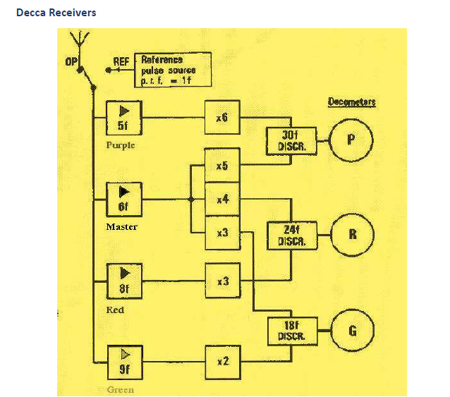  Explanation – 6 Marks  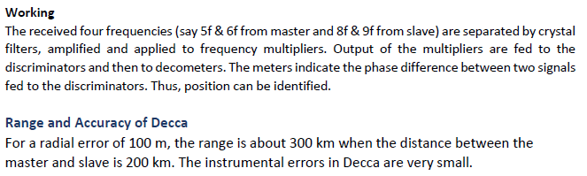  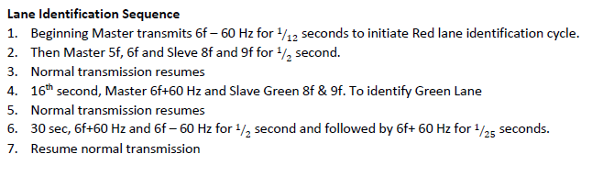  (OR)  - With the aid of pictorial representations explain the reception process of Instrument Landing System (ILS).  Answer:  Diagram – 5 Marks  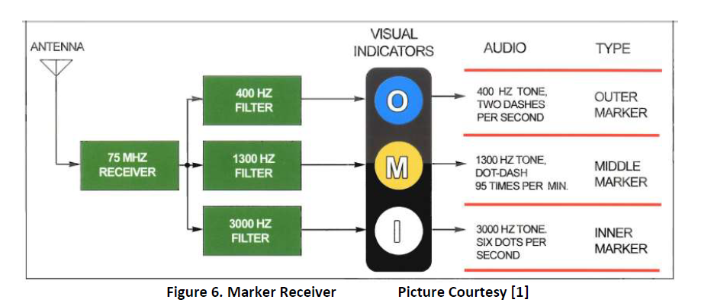  Explanation – 7 Marks  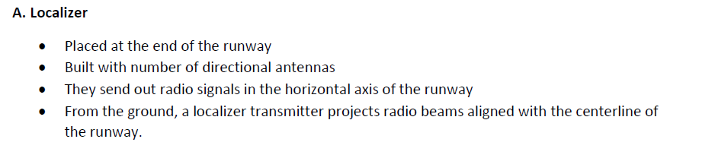  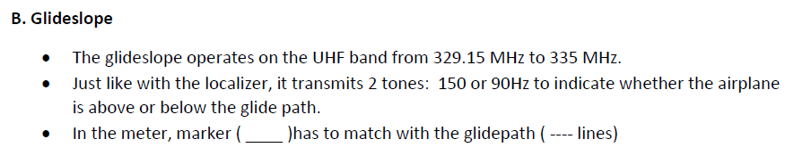  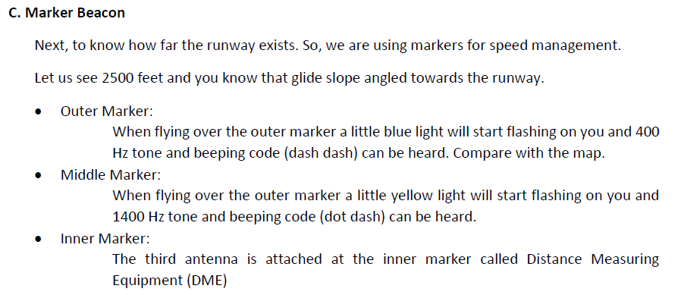 | 12 | 3 | 5 | 4

Approved by the Course Coordinator Signature of the Question paper setter

Signature of the Academic Advisor

